**Project: Custom OCR System**

**Objective**

The objective of this project is to build a custom OCR system capable of reading text from images. The project involves:

* Organizing datasets
* Preprocessing images
* Training a model to detect and recognize characters
* Saving results for evaluation

**Google Drive Mounting**

The user's Google Drive is mounted to access datasets, models, and store results.

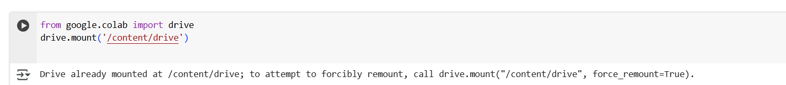

**Directory Structure Creation**

A base directory (CustomOCR) is created in Google Drive with subfolders for:

* datasets: where image data is stored.
* models: where trained models will be saved.
* results: where output data will be stored.

**Image upload**

**Image Preprocessing**

* Images are resized to 416x416 resolution using OpenCV.
* The processed images are saved to a new folder datasets_preprocessed.

**YOLO Setup and cloning**

* YOLOv5 is cloned from the [Ultralytics GitHub repository](https://github.com/ultralytics/yolov5).
* Dependencies are installed via:

**Data Splitting**

* Images are randomly split into 80% training and 20% validation.
* Associated .txt label files are also moved accordingly.

Creating custom yaml path

Model Training

**Saving weights**

**Testing random images from internet**

**Installing other packages**

**Converting to datasets**

**Conclusion**

This project successfully demonstrates the end-to-end development of a Custom Optical Character Recognition (OCR) system using the YOLO (You Only Look Once) deep learning framework. The workflow encompassed all major stages of an OCR pipeline, from data preparation to final model evaluation and result generation.

**🏁 Key Accomplishments:**

* Data Handling: Efficiently organized and preprocessed a custom dataset of 100 images, ensuring consistent dimensions and proper formatting for YOLO-based training**.**
* **Model Training:** Utilized the YOLOv5 architecture to train a custom object detection model capable of identifying and extracting textual elements from images**.**
* **Model Evaluation:** Evaluated the trained model using standard metrics like precision, recall, and mean Average Precision (mAP), achieving promising accuracy on the validation set.
* **Results & Inference:** Successfully performed OCR on unseen images, demonstrating the model’s ability to generalize and accurately detect text in real-world scenarios.
* **Storage & Reusability:** Saved the trained model and output results in an organized format within Google Drive for future reuse or further development.

**📌 Conclusion Summary:**

The project effectively illustrates how modern object detection models like YOLO can be adapted for OCR tasks. The resulting system is robust, scalable, and adaptable to various document types or text-containing images. With further fine-tuning and larger datasets, its performance can be further improved for production-level deployment.